Middle Park Primary School
Safeguarding/Child Protection Policy
2026 - 2027



Date ratified by Governors: | Sept 2026 | Date policy was shared with all staff: | Sept 2026 | Date of next review of the policy: | 1.9.2027

Name of Co-Headteachers: | Carrie Specht and Terri Adams
Name of Designated Safeguarding Lead for Child Protection: | Carrie Specht
Name(s) of Deputy Designated Safeguarding Leads for Child Protection: | Claire Evans (KS2)  Emma McCarron (KS1 and FS)
Name of Designated Teacher for Looked-after Children: | AnnMarie Lewis
Name of IT manager/person in charge of E-Safety: | Charlotte Parody
Name of Governor for Safeguarding/Child Protection: | Norma Spruce
Name of Chair of Governors: | Carol Ladbrook
Name and contact details of  Royal Borough of Greenwich LADO: | Sadie Bates 0208 921 3930  (mobile 07561116174)  Childrens-LADO@royalgreenwich.gov.uk
Name and contact details of  Royal Borough of Greenwich Schools’ safeguarding Officer: | Laura Lumbis 0208 921 3930  (mobile 07896781040)

Contents
1. Policy Statement 4
2. Definition of Safeguarding 4
3. Aims and Values 5
4. Roles and Responsibilities 5
4.1 The Governing Body’s Roles & Responsibilities 5
4.2 Head Teacher’s Role and Responsibilities 6
4.3 The Designated Safeguarding Lead’s Role and Responsibilities 8
4.4 How a child can raise a concern themselves 9
4.5 The Role & Responsibilities of Staff and Volunteers 10
5. Strategies and Procedures to Support Safeguarding 11
5.1 Promoting Equality 11
5.1.2 Children who are questioning their gender 12
5.2 Trained Workforce 13
5.3 Safer Recruitment 14
5.4 Embedding High Standards of Behaviour 15
5.5 Promoting online safety through a whole school approach. 16
5.6 Referral to Family and Adolescent Support Services (previously called Early Help) – KCSiE has changed to Family Help 16
5.7 Recognising Abuse and Taking Action 17
5.8 Reporting Concerns and Record Keeping (see also Appendix 3 ) 18
6. Dealing with Concerns/Allegations Made Against School Staff, Supply Staff, Trainee Teachers, Volunteers and Contractors 18
7 Dealing with Concerns/Allegations Against Other Children – Child on Child Abuse (including harassment and violence) 20
8 Information Sharing 20
9 Communication with Parents 21
10 Monitoring and Evaluation 21
11 Linked Policies/Procedures 21
Appendix 1: Types and Indicators of Abuse 22
Appendix 2 Statutory Guidance, Legislation and Advice: 33
Appendix 3: Child Protection Recording and Referral…………………………………….34
Appendix 4: Managing and Reporting Concerns or Allegations Against School Staff, Supply Staff, Volunteers and Contractors 38
Appendix 5: Concern Form 38
Appendix 6: Searching pupils for prohibited and banned items 42
Appendix 7: Brookes Traffic Light Tool ……………………………………………………………….44
Appendix 8: How the school meets the Digital Technology in Schools’ Standards 47

Policy Statement
As a school, we recognise our moral and statutory duty to safeguard and promote the welfare of all children.
We endeavour to provide a safe and welcoming environment where children and adults feel respected and valued.
At Middle Park Primary school, we are committed to safeguarding children and young people, and we expect everyone who works in our school to share this commitment. We maintain an attitude of ‘it could happen here’ where safeguarding is concerned and promote a culture of openness and vigilance where children have a voice and are listened to. We promote an inclusive, anti-discriminatory culture where racism, and other forms of discriminatory behaviour are recognised, challenged and addressed as part of their safeguarding responsibilities. Ultimately, all systems, processes and policies should operate with the best interests of the child at their heart.
Adults in our school take all welfare concerns seriously and encourage children and young people to talk to us about anything that worries them. We will always act in the best interest of the child.
Staff should share any concerns they have about a child with the Designated Safeguarding Lead. However, it should be remembered that sometimes children will not feel ready or know how to tell someone that they are being abused, exploited, or neglected, and/or they may not recognise their experiences as harmful. This should not prevent staff from having professional curiosity and speaking to the DSL.
This policy provides staff, volunteers and governors with the framework required in order to keep children safe and secure in our school. Its purpose is also to inform parents and carers of how we will safeguard their children whilst they are in our care.
The procedures contained in this policy apply to all staff, volunteers and governors and are consistent with those of the Greenwich Safeguarding Children’s Partnership (GSCP) and locally agreed procedures.
This policy takes account of the ‘Keeping Children Safe in Education’ statutory guidance and makes frequent references to it. KCSiE 2026 came into force on 1 September 2026.
This policy provides information regarding different types of abuse and encompasses other statutory and non-statutory documentation and legislation (shown in Appendix 2 of this policy).
The policy outlines the procedures that the school has in place to ensure all children in our care receive effective support, protection and justice. Preventative education is effective within our whole school approach and prepares children for life in modern Britain with a zero tolerance for sexism, misogyny/misandry, homophobia, bi-phobic and sexual violence/harassment.
The policy is hyperlinked to relevant statutory documentation and guidance to provide easy access for additional information/clarification.

2. Definition of Safeguarding
As defined in statutory guidance
- providing help and support to meet the needs of children as soon as problems emerge.
- protecting children from maltreatment, whether that is within or outside the
home, including online.
- preventing the impairment of children’s mental and physical health or development.
- ensuring that children grow up in circumstances consistent with the provision of safe and effective care.
- taking action to enable all children to have the best outcomes.

3. Aims and Values
3.1 Aims
- To ensure all staff are aware of their statutory duty to safeguard the children in their care.
- To ensure staff are trained to recognise and report safeguarding concerns, ensuring appropriate action is taken in a timely manner to safeguard and promote children’s welfare.
- To support the development and understanding of children in how to protect themselves from potential abuse and equip them with the skills needed to support their mental wellbeing.
3.2 Values
- To uphold children’s rights to feel safe and protected from harm.
- To work effectively in partnership with other agencies for the benefit of children.
- To ensure the interest of the child is paramount in all safeguarding decisions made and actions taken.

4. Roles and Responsibilities

4.1 The Governing Body’s Roles & Responsibilities
4.1.1 'Schools and colleges have a pivotal role to play in multi-agency safeguarding arrangements. Governing bodies and proprietors should ensure that the school or college contributes to multi-agency working in line with statutory guidance Working Together to Safeguard Children.'
Governors promote a child-centred whole school approach to safeguarding which underpins all relevant aspects of process and policy development, and promote a culture of respect, where staff and children are listened to, and all concerns raised are followed up.
4.1.2 The Governing body has nominated a governor who will be responsible for Safeguarding and Child Protection and has ensured that all governors (including those new to the role) have a clear understanding of their statutory responsibility to safeguarding those who use the school.
4.1.3 The Governing Body will ensure that:
- An annual review of the school’s safeguarding policy procedures adheres to the Royal Borough of Greenwich guidance and locally agreed interagency procedures.
- The safeguarding policy is made available publicly, on the school website or on request.
- The safer recruitment procedures as outlined in KCSiE part 3 are robustly implemented and all appropriate checks are carried out on staff and volunteers who work with children.
- The school has a behaviour policy which includes measures to prevent bullying of all types.
- A senior member of the school’s leadership team is designated to take lead responsibility for dealing with safeguarding and child protection (including online safety). To provide advice and support to other staff, liaising with the local authority, and working with other agencies. Governing bodies and proprietors should ensure the designated safeguarding lead has the appropriate status, authority, skills and experience within the school or college to carry out the duties of the post. The role carries a significant level of responsibility and the postholder should be given the additional time, funding, training, resources, and support needed to carry out the role effectively.
- Annual staff training is prioritised to ensure all staff are equipped to carry out their responsibilities for child protection effectively. Also, that all temporary staff and volunteers who work with children are made aware of the school’s arrangements for child protection and their responsibilities.
- The expectations of safeguarding responsibilities contained within the Teacher standards and the Staff code of Conduct Policy are met.
- The school has clear systems and processes in place for identifying possible mental health concerns, including routes to escalate response and clear accountability systems.
- There are robust systems in place for the induction of new staff on the school’s safeguarding procedures and relevant policies (CP policy, behaviour policy, staff code of conduct, procedures to keep children safe when using online technology, procedures regarding children missing education and the role of the DSL).
- An appropriate whistleblowing policy/procedure is in place to encourage any staff member or volunteer to report concerns regarding safeguarding practice in school.
- The school has clear procedures for dealing with allegations of abuse made against members of staff and volunteers that comply with guidance from the local authority and locally agreed interagency procedures.
- Procedures are in place for regular evaluation of the effectiveness of safeguarding systems, including adherence to safer recruitment procedures and checks on the effectiveness of online safety, including filtering and monitoring strategies, to ensure the standards are being met. In line with KCSiE 2026, the filtering and monitoring review will take place at least once every academic year and will be recorded. See also Appendix 7 of this policy.
- With staff welfare in mind, the Governing Body will consider the necessity and appropriateness of arranging for ‘Safeguarding Supervision’ for the DSL and Deputy DSLs within the school.

4.2 Head Teachers Role and Responsibilities
In line with the statutory guidance (KCSiE 2026), the Head Teachers will ensure that systems and procedures are in place to support all staff to understand their individual and collective roles in safeguarding and promoting the welfare of children.
The Head Teachers will ensure:
- The policies and procedures adopted by the governing body or proprietor are fully implemented and followed by all staff.
- The DSL has a clear and concise job description, explicitly referring to the role of taking lead responsibility for safeguarding and child protection (including online safety and understanding the filtering and monitoring systems and processes in place).
- Sufficient resources and time are allocated to enable the DSL and other staff to discharge their responsibilities, including taking part in strategy discussions and other inter-agency meetings, and contributing to the assessment of children.
- All school staff will receive appropriate safeguarding and child protection training at induction. This training will be regularly updated in line with statutory guidance and local safeguarding partnership requirements. In addition, all staff will receive safeguarding and child protection updates, as required and at least annually, to provide them with the relevant skills and knowledge to safeguard children effectively.
- To ensure continuity of safeguarding responsibilities, schools should implement robust cover arrangements for periods when the designated safeguarding lead is unavailable due to illness, leave, or other circumstances.
- All staff and volunteers feel able to raise concerns about poor or unsafe practice with regard to children, and such concerns are addressed sensitively and effectively in a timely manner in accordance with agreed whistleblowing policies, where appropriate.
- There are arrangements in place for DSL availability to cover any out of hours or out of term time activities taking place.
- Induction procedures are robust and meet the requirements outlined in KCSiE 2026
- A barred list check is completed, and a risk assessment is in place, to ensure any individual who starts before a DBS certificate is received is appropriately supervised.
- Procedures are in place to refer to DBS any person dismissed or removed from their role due to safeguarding concerns.
- The school will take the lead role in the investigation of any allegation concerning a supply teacher in post and will keep the supply agency informed throughout.
- The school is responsible for the pupils they place in any alternative provision and for ensuring the provider has appropriate safeguarding procedures in place.
- The school is satisfied that any visitors attending in a professional capacity or organisations using the school premises have appropriate safeguarding procedures in place.
- The school curriculum provides regular opportunities for children to learn about personal safety and how to protect themselves from harm in an age-appropriate way.
The Alternative Provision (AP) section has been expanded for clarification, and to reflect existing AP guidance (KCSiE 2026 update):

When a pupil is placed with an AP provider, settings are directed to:
- Obtain written confirmation that appropriate safeguarding checks have been carried out on individuals working at the establishment
- Receive notification of any arrangements that may put the pupil at risk
- Remain fully aware of where a pupil is based during school/college hours
- Review AP placements at least half termly
- Review and potentially terminate any placements where safeguarding concerns arise.

4.3 The Designated Safeguarding Lead’s Role and Responsibilities
The DSL will act to meet the requirements of the role, as outlined in KCSiE 2026 Annex B, which is summarised as: taking lead responsibility for safeguarding and child protection (including online safety and understanding the filtering and monitoring systems and processes in place). Requirements of the role include (but is not limited to):
Raising awareness The designated safeguarding lead should:
• ensure each member of staff has access to, and understands, the school or college’s child protection policy and procedures, especially new and part-time staff,
- ensure the school or college’s child protection policy is reviewed annually (as a minimum) and the procedures and implementation are updated and reviewed regularly, and work with governing bodies or proprietors regarding this,
- ensure the child protection policy is available publicly and parents know that referrals about suspected abuse or neglect may be made and the role of the school or college in this,
- link with the safeguarding partner arrangements to make sure staff are aware of any training opportunities and the latest local policies on local safeguarding arrangements, and
- help promote educational outcomes by sharing information about welfare, safeguarding and child protection issues that children who have or have had a social worker are experiencing with teachers and school and college leadership staff.
- Referring cases of suspected abuse, neglect, radicalisation or allegations to the relevant statutory agencies (children’s social care, the police or the Channel programme).
- Act as a source of support, advice and expertise to staff within the school.
- Liaise as appropriate with staff, including IT technician, the SENCo, the designated teacher for LAC, the Virtual School Head and the named person with oversight for mental health.
- The role of the Virtual School Heads now includes a non-statutory responsibility to “promote the educational achievement of all children in kinship care.” Recognising attendance as a key factor in safeguarding, Virtual School Heads should work with local authorities to set and report on ambitious targets to improve their attendance.
- Promote positive engagement with parents and/or carers to safeguard children and support families facing challenging circumstances.
- Champion educational outcomes for vulnerable children and those who have or have had a social worker.
- Have procedures in place to re-assess concerns when a child’s situation fails to improve.
- Ensure procedures and guidance are in place to ensue all searches of pupils are witnessed (including the appointment of an appropriate adult for strip searches ) and all searches for prohibited items are logged on the school safeguarding reporting system. See also guidance in appendix 6.
- Filtering & monitoring responsibilities, including reviews at least every academic year (as set out in Appendix 7) should be carried out by the SLT member responsible for filtering and monitoring, with the support of the school's designated safeguarding lead and IT support.

4.3.1 Record keeping
- Maintain clear, concise and confidential records of the concern, action taken and outcome
- Ensuring safe and secure transfer of records when a child leaves the school.
- Risk assessments to be used appropriately

4.3.2 Promoting a culture of safeguarding and training
- Maintain their own secure and up-to-date knowledge of safeguarding developments and share as appropriate with staff in line with advice from the Greenwich Safeguarding Children’s Partnership (GSCP).
- Understand the assessment process for providing early or Family Help and intervention, for example through locally agreed common and shared assessment processes, such as the Royal Greenwich Family Help Guidance and FaASS referral procedures.
- Have a working knowledge of how local authorities conduct a child protection case conference and a child protection review conference and be able to attend and contribute to these effectively when required to do so.
- Ensure each member of staff has access to and understands the school’s safeguarding/child protection policy and procedures, especially new or part-time staff.
Ensure all staff have robust induction training and should include: the child protection policy; the behaviour policy; the staff code of conduct; the safeguarding response to children who go missing from education; and the role of the designated safeguarding lead. Ensure new staff are confident to recognise and report any concerns about children’s safety and welfare immediately as they arise.
- Promote a culture of listening to children and building trusting relationships to support those children who find difficulty in approaching staff with a concern.
- Ensure all staff are aware of the additional risks that children with Special educational needs and disabilities face online and offline.
- Ensure all staff are aware of the guidance What to do if you are worried a child is being abused
- Ensure staff are aware of contextual safeguarding and extra-familial harm from the influence of factors outside of school or in the child’s own family, including vulnerability to possible abuse, exploitation and youth violence.
- Provide feedback and reassurance to staff who have raised a child protection concern

4.4 How a child can raise a concern themselves
Children are able to use a worry box, a trusted adult, a school council rep or Inclusion ambassador, a trusted friend, outside agency i.e. SALT or CAMHS. Any child that raises a concern will be informed that a member of the DSL team will be notified. Follow up and check ins.
Children at Middle Park Primary school are taught about how they can keep themselves and others safe, including online. To be effective, we present this information in an age-appropriate way. We are sensitive to the specific needs and vulnerabilities of individual children, including children who are victims of abuse, and children with special educational needs or disabilities.

4.5 The Role & Responsibilities of Staff and Volunteers
4.5.1 At the start of the academic year, or commencement of employment if starting at the school during the academic year, all staff will sign a declaration to indicate that they have read and understood ‘Keeping Children Safe in Education’ Part One in full and the school’s Safeguarding/Child Protection Policy. Staff working directly with children will also read the relevant annexes, including Annex B where applicable. In signing this, staff are indicating that they understand their statutory duty to safeguard children and to report any concerns.
4.5.2 All staff will familiarise themselves with the signs of abuse, neglect and exploitation (Appendix 1, attached) so that they are able to identify children who may be in need of help or protection.
4.5.3 All staff will ensure they understand and can follow the school’s procedures for reporting concerns
4.5.4 Staff members will maintain an attitude of ‘it could happen here’ where safeguarding is concerned. When concerned about the welfare of a child, staff members should always act in the interests of the child.
4.5.5 All staff will:
- Be aware that mental health problems can be an indicator that a child has suffered abuse, neglect or exploitation
- Recognise that a disclosure may come directly from the child, or from a third party, e.g., friend, neighbour, other family member. Alternatively, it may be through the suspicion of staff based on a variety of signs, symptoms and knowledge of possible indicators of abuse
- Recognise that child-on child abuse (all forms, including physical and sexual violence and harassment, nudes/semi-nudes, ‘up skirting’, bullying and initiation/hazing) must not be downplayed and must be taken seriously and appropriately reported.
- All staff should recognise that children may experience prejudice-based harm, including racism, faith-based prejudice, and other forms of discrimination. Such experiences may significantly affect a child's welfare, wellbeing, mental health, and willingness to seek help. Staff should be alert to the signs and impact of prejudice-based harm and ensure that concerns are considered within safeguarding practice where appropriate.
- Be aware of indicators which may signal involvement with violent crime (absences from school, changes in friendship groups or relationships with older individuals/groups, decline in performance or unexplained injuries). Also, the increased likelihood of involvement of being male or permanently excluded from school.
4.4.6 Staff will take seriously any disclosures made to them and provide reassurance to the discloser through their responses and behaviour (without promising they will not tell anyone). Ensuring the victim or person disclosing is not given the impression they are causing a problem by reporting a concern or abuse.
4.4.7 Staff will read carefully any documentation provided by the DSL to update their safeguarding training.
4.4.8 All staff and volunteers have a duty to raise concerns about poor or unsafe practice and potential failures in the school’s safeguarding regime. Where a staff member feels unable to raise an issue or feels that their genuine concerns are not being addressed, other whistleblowing channels are open to them
- The NSPCC whistleblowing helpline is available for staff who do not feel able to raise concerns regarding child protection failures internally. Staff can call: 0800 028 0285 – line is available from 8:00 AM to 8:00 PM, Monday to Friday and Email: help@nspcc.org.uk.

5. Strategies and Procedures to Support Safeguarding

5.1 Promoting Equality
5.1.1 Some children have an increased risk/vulnerability to abuse. They can face additional barriers with respect to recognising or disclosing concerns. The school is committed to anti-discriminatory practice and recognise children’s diverse circumstances. We ensure that all children have the same protection, regardless of additional barriers they may face.
At Middle Park Primary school, we recognise that when a child has a social worker, it is
an indicator that the child is more at risk than most pupils. This may mean they are more vulnerable to further harm, as well as facing educational barriers to attendance, learning, behaviour and mental health. We take these needs into account when making plans to support pupils who have a social worker.

Children who may also be more vulnerable include:
- Children who may experience discrimination due to their race, ethnicity, religion, sex, sexual orientation, gender reassignment or because they are questioning their gender.
- Those who have English as an additional language.
- Children known to be living in difficult situations – for example, temporary accommodation or where there are issues such as substance abuse or domestic abuse.
- Children at risk of FGM, sexual exploitation, forced marriage, or radicalisation/exploitation.
- Children who are asylum seekers or at risk of modern slavery/trafficking.
- Those at risk due to either their own or a family member’s mental health needs.
- Children looked after, previously looked after or privately fostered.
- Children frequently missing from education, home or care.
- A child whose parent/carer has expressed an intention to remove them from school to be home educated.

5.1.2 Children who are questioning their gender
KCSiE 2026 places guidance on children who are questioning their gender within the statutory safeguarding framework. The school will respond in a child-centred, cautious and evidence-informed way, recognising that these matters may involve safeguarding, welfare, equality, confidentiality, parental responsibility, data protection and the rights, safety, privacy and dignity of all children. The school will not treat a child questioning their gender as a safeguarding concern in itself; however, staff must consider whether the child may have additional vulnerabilities, unmet needs, mental health concerns, bullying, harmful online influences, family tensions or other risks that require support or safeguarding action.
Where a child simply confides in a member of staff about feelings relating to gender but does not request any change in how they are treated at school, staff should respond sensitively, listen without judgement, avoid making assumptions or promises of confidentiality, and follow normal safeguarding procedures if any concern about the child’s wellbeing or safety arises.
Staff must pass any request for support or change to the DSL promptly and factually. The DSL will consider whether the request raises any safeguarding, welfare or wellbeing issues and will ensure that the child is supported by an appropriate trusted adult while the matter is considered. Staff should not advise, encourage or discourage a child to take any particular course of action, and should avoid making assurances about outcomes before the DSL and senior leaders have considered the matter.
If a child or parent/carer requests a change relating to social transition, including a change of name, pronouns, uniform, facilities, sports participation or other day-to-day arrangements, staff must refer the request to the DSL before any changes are made. The school will not initiate social transition, and individual staff must not make informal changes unless a school-level decision has been made.
The DSL will lead a recorded safeguarding consideration of the request, taking account of the child’s age and maturity, voice and lived experience, any SEND or mental health needs, peer relationships, family context, clinical input where available, relevant records, and any impact on other children. Decisions will be made on a case-by-case basis, with senior leadership oversight and clear written records of the rationale, actions agreed and review points.
The school’s consideration will include listening to the child’s views; considering the child’s age, maturity and wider circumstances; checking whether there are safeguarding, SEND, mental health, attendance, bullying or online safety concerns; considering the views of parents and carers unless doing so would increase risk; and assessing the implications for other children and for the safe, fair and lawful operation of the school.
Parents and carers should ordinarily be involved, and their views should carry great weight, unless the DSL judges that involving them would place the child at greater risk of harm. Where there is disagreement between parents/carers, or uncertainty about the child’s best interests, the school will seek advice from appropriate safeguarding, local authority, legal or clinical sources before confirming arrangements.
Where the school identifies a safeguarding concern, staff will follow the usual child protection procedures in this policy, including seeking advice from children’s social care, the local authority safeguarding team, the LADO or other relevant professionals where appropriate. Where there is no safeguarding concern, but the child needs pastoral support, the school will agree proportionate support arrangements and review them regularly.
The school will maintain clear arrangements for single-sex spaces and sport in line with statutory guidance, while considering reasonable alternative provision where needed to protect the safety, comfort, privacy and dignity of the child and of other children. Any alternative arrangements will be risk assessed, clearly recorded and reviewed.
Records relating to a child questioning their gender will be kept securely, shared only with those who need to know in order to safeguard or support the child, and managed in line with data protection, confidentiality and record-keeping expectations. Any agreed arrangements will identify who is responsible for communicating with the child, parents or carers, staff and relevant professionals.
This approach should be read alongside the school’s safeguarding, equality, behaviour, anti-bullying, attendance, records, confidentiality, online safety, SEND, mental health and RSHE policies. Staff training will include the KCSiE 2026 expectations on gender-questioning children so that staff know how to respond, record concerns and refer requests to the DSL, avoid informal arrangements and follow safeguarding procedures where concerns arise.
5.1.3 Children who are Young Carers
The school recognises that caring responsibilities can impact on their attendance, attainment, behaviour and wellbeing. Early identification is essential to ensure young carers receive support at the right time and by the appropriate services including additional support from external partners, or local authority and health services.
At Middle Park Primary school, we identify during the admission process. Our Young Carers are registered on our MIS system and referrals are made to an outside agency who support Young Carers.
5.1.3 The school recognises that children with special educational needs or disabilities (SEND) or those with certain health conditions can face additional safeguarding challenges. Additional barriers can exist when recognising abuse, neglect or exploitation.
The school provides extra pastoral support and attention for these children, along with ensuring any appropriate support for communication is in place.
Staff recognise the need to:

- Explore the reasons for changes in behaviour, mood and injury rather than assume it is related to the child’s disability

- Recognise these children as being more prone to peer group isolation or bullying (including prejudice-based bullying) than other children

- Understand that children with SEN and disabilities can be disproportionally impacted by things like bullying without outwardly showing any signs

- Communication barriers and difficulties in managing or reporting these challenges, risks that they do not understand that what is happening to them is abuse
- the need for intimate care or that these children are isolated from others
- That these children are more likely to be dependent on adults for care
- Issues over cognitive understanding — being unable to understand the difference between fact and fiction in online content and then repeating the content/behaviours in school, or the consequences of doing so.
- In KCSiE 2026 in the section on the Cass review, the term “spectrum disorder” has been removed. This is to align the guidance with the SEND code of practice.

5.2 Trained Workforce
    - All staff members will receive appropriate safeguarding and child protection training which is regularly updated. In addition, all staff members will receive safeguarding and child protection updates, including KCSiE 2026 changes on Part One reading expectations, Family Help terminology, online safety, mental health support, gender-questioning children and safer recruitment, as required to provide them with relevant skills and knowledge to safeguard children effectively.

    - The designated safeguarding lead (and any deputies) will undergo training to provide them with the knowledge and skills required to carry out the role. This training will be updated at least every two years. The designated safeguarding lead will undertake Prevent awareness training and disseminate information to staff.
    - Any newly appointed DSL will attend the DSL one-day training, provided by the Royal Borough of Greenwich Direct Services to Schools, or another accredited training provider, followed by the GSCP Working Together course, before taking lead responsibility for safeguarding. The deputy DSL will take a leading role on safeguarding for the short time that the DSL is waiting to receive training.
    - All governors will receive annual safeguarding training to support them in understanding their statutory duties. All new governors will have safeguarding training as part of their induction. The designated Governor for Safeguarding and Child Protection will undertake governor safeguarding training annually.
    - The DSL will maintain a training record indicating the attendance at safeguarding training so that absent staff can receive an update on their return. Additionally, the DSL will retain a record showing staff have read KCSiE (Part 1 and Annex B).
    - All new members of staff will receive safeguarding training as part of their induction programme.
    - At least one member of every appointment panel will have gained accreditation through Safer Recruitment training (statutory requirement).

5.3 Safer Recruitment
The statutory guidance will be followed (see KCSiE 2026 Part 3). This includes:
- References to the Teaching Regulation Agency (TRA) Secure Access system have been removed and replaced. Schools and colleges are now directed to the Check a teacher’s record service to make GTCE, prohibition, direction, restriction, and children’s barred list checks.
- In the “Maintained school governors” section, a reference to the Employer Secure Access sign-in portal via the TRA Teacher Services web page has been removed and replaced. To check if a person proposed to be a governor is barred as a result of being subject to a section 128 direction, schools and colleges are directed to the Government’s list of individuals prohibited from managing or governing schools.
- KCSiE 2026 update: Safer recruitment procedures will reflect the removal of the supervision exemption from regulated activity and any resulting changes to barred list and DBS checks for staff, volunteers and others working with children.
- With the introduction of the Crime and Policing Act 2026, there have been changes to what classes as a regulated activity. Until now, if someone was supervised whilst undertaking a regulated activity, then they did not require an enhanced DBS check. After the 1st of September 2026 this changes and anyone undertaking a regulated activity regardless of whether they are supervised or not requires an enhanced DBS with barred list check. The full definition of what is classed as a regulated activity can be found on p.81 of the 2026 version of KCSiE.
This will require relevant policies to be updated in relation to employment, staffing and use of volunteers in the setting. For further information see the section on “Regulated activity and DBS” below.
Any person volunteering in a school or college in a role that involves teaching, training, instructing or supervising children frequently or on more than 3 days in a 30-day period or overnight is now in regulated activity.'
Existing volunteers who newly fall into regulated activity from 1 September 2026 must be checked (enhanced DBS + barred list, or in defined circumstances a standalone barred-list check). The 3-day/30-day threshold counts cumulatively across settings — if a volunteer helps at more than one school or college, the schools should work together to decide who obtains the check.
Where schools are also subject to the EYFS framework, volunteers must not be permitted to begin working within the settings covered by the EYFS framework until the school or maintained nursery school has received the volunteer’s enhanced DBS certificate including barred list information.
Volunteers who are not in regulated activity should still have a written risk assessment on file, considering the nature of the role, what the school knows about the volunteer, and whether a lower level of check (an enhanced DBS without barred list, or a basic DBS) is appropriate.
- Outlining the school’s commitment to safeguarding and promoting the welfare of children in all advertising.
- At least one safer recruitment trained adult will undertake the shortlisting and be present on any interview panel.
- Providing a copy or link to the school’s CP/ safeguarding policy to applicants.
- Requesting a self-declaration at interview so any relevant information can be discussed.
- Seeking references prior to interview and checking employment history.
- Following shortlisting, carrying out pre-employment checks (including the applicant’s online presence).
- The shortlisted applicant should be required to sign a hard copy of the application at interview to confirm that the information they have given is true (applicable for online applications received).
- All interview documentation should be retained in the staff file of the successful applicant.
- Recording required information on the school’s Single Central Record.

5.4 Embedding High Standards of Behaviour
The school’s behaviour policy promotes positive and respectful behaviour of staff and pupils.
5.4.1 All school staff have been trained to challenge any child-on-child abuse in all its forms. (see Appendix 1 in this policy).
- Staff will challenge derogatory or sexualised language and inappropriate behaviours including that carried out online.
- Deliver a curriculum to educate children about appropriate behaviour and developing positive relationships.
- Staff will tackle prejudice and promote empathy through awareness and acceptance of differences. A whole school approach will be adopted to tackling sexism and challenging homophobic language, banter and racist language.
- Staff will be vigilant concerning all forms of bullying physical, emotional and verbal.

5.5 Promoting online safety through a whole school approach.
- Ensuring staff have appropriate training to understand and reduce the risks associated with content, contact, conduct and commerce (4 C’s). In KCSiE 2026, online safety guidance includes misinformation, disinformation, conspiracy theories, AI-generated abuse and deepfake or AI-generated intimate images.
- Actively promoting online safety within policies and procedures in the school and engaging with parents.
- Ensuring the online policy has clarity on the use of mobile and smart technology and address is the risks associated with the 4 C’s above.
- There are appropriate filtering and monitoring systems in place with regular review to determine their effectiveness (meeting the DFE filtering and monitoring standards requirements).
- The effectiveness of filtering and monitoring arrangements will be reviewed at least once every academic year, recorded, and reported through the school’s safeguarding governance arrangements. The school’s mobile and smart technology expectations will be clear and consistent with the online safety policy.

5.6 Referral to Family and Adolescent Support Services
Royal Greenwich FaASS supports children and families with emerging needs and promotes a shared responsibility to facilitate significant and sustained change in children’s lives, building resilience, preventing and protecting children from harm. FaASS is focused on developing and breaking intergenerational cycles of poverty through working with children’s parents/carers and families.
Any child may benefit from support before statutory intervention, including from universal services and community-based Early Help, or the targeted level of Family Help (FaASS). All school and college staff should be particularly alert to the potential need for additional support for a child who:
● is disabled or has certain health conditions and has specific additional needs
● has special educational needs (whether or not they have a statutory Education, Health and Care plan)
● has a mental health need
● is a young carer
● is pregnant and/or is a parent themselves
● has exhibited early signs of abusive, violent and/or harmful behaviours
- is showing signs of being drawn in to anti-social or criminal behaviour, including gang involvement and association with organised crime groups or county lines
● is frequently missing/goes missing from education, home or care
● has been repeatedly removed from the classroom, experienced multiple suspensions, is on a part-time timetable, is at risk of being permanently excluded from schools, colleges and in Alternative Provision or a Pupil Referral Unit
● is at risk of exploitation, modern slavery, trafficking, including criminal or sexual exploitation
● is at risk of being radicalised into terrorism
● has a parent or carer in custody, or is affected by parental offending
● is in a family circumstance presenting challenges for the child, such as drug and alcohol misuse, adult mental health issues and domestic abuse
● is misusing alcohol and other drugs themselves
● is at risk of honour or faith-based abuse such as Female Genital Mutilation or Forced Marriage, and
● is a privately fostered child.

Further information can be found from:
www.greenwichsafeguardingchildren.org.uk

MASH consultation line 0208 921 2267
Mash-referrals@royalgreenwich.gov.uk

www.Greenwichcommunitydirectory.org.uk

5.7 Recognising Abuse and Taking Action
5.7.1 All staff and volunteers must be aware that the main categories of abuse are:
- Neglect
- Physical abuse
- Sexual abuse
- Emotional abuse

5.7.2 All staff and volunteers must act in accordance with this policy if a child presents with indicators of abuse.
5.7.3 Staff will follow the guidance in this policy for dealing with a disclosure or reporting concerns (see Appendix 3).
5.7.4 If any member of staff has a concern about a particular child in their care, they must immediately report their concerns to, and seek advice from the Designated Safeguarding Lead, or in their absence, the Deputy Designated Safeguarding Lead. Staff must provide the DSL with a signed and dated written/electronic record of their concerns.
5.7.5 All staff should be aware of the process for making referrals to children’s social care and for statutory assessments under the Children’s Act 1989, especially section 17 (children in need) and section 47 (a child suffering, or likely to suffer, significant harm) that may follow referral, along with the role they might be expected to play in such assessment.
5.7.6 Staff will follow the guidance in Appendix 3 of this policy if a child discloses that he/she has been abused in some way.
5.7.7 Staff must be aware that an incident may eventually end up as a court case and children's evidence can all too easily be compromised by leading questions or personal expressions/comments when recording the disclosure.
5.7.8 The DSL (or in his/her absence, the Deputy DSL) will make the decision whether or not to refer the concern to Social Care. The Multi Agency Safeguarding Hub (MASH) will be consulted when there is uncertainty about whether to refer.
MASH Consultation Line for professionals Tel- 0208 921 2267 or contact
RBG Schools’ Safeguarding Officer.

5.7.9 Referrals will be made as soon as possible by telephone and the appropriate forms completed and sent at the same time. Referrals to Children's Social Care must be made to the Multi Agency Safeguarding Hub (MASH) Tel 0208 921 3172 or complete an Inter-agency-referral-form which can be downloaded from Agency Referrals - Greenwich Safeguarding Children Partnership

Multi Agency Safeguarding Hub
Children’s Services’
Safeguarding and Social Care, 1st Floor
The Woolwich Centre,
Wellington Street,
Woolwich, London
SE18 6HQ

5.7.10 If the DSL has raised a safeguarding concern but does not feel that appropriate action has been taken by Royal Borough of Greenwich Children’s Services, he/she should use the RBG Safeguarding Children’s Partnership escalation policy to take this further. (This is available on the GSCP website, click on the professional’s tab)

5.8 Reporting Concerns and Record Keeping (see also Appendix 3 )
5.8.1 The school uses an electronic system Safeguarding Concern, for recording concerns. If an electronic system is used in in the school any paper notes etc must be scanned and held electronically. These documents provide an accurate factual account of the concern and action taken by the school.
5.8.2 The completed records will be kept for the duration of the child's school career and where a child changes school the records will be forwarded securely to the new setting.
5.8.3 Records will include
- Clear and comprehensive summary of concern
- Details of how concern was followed up
- Note of any action taken, decision reached and outcome
5.8.4 The information contained will be regarded as confidential. Any request for access to the information by non-Greenwich Safeguarding Children Partnership Agencies (e.g., Solicitor, investigating agent) will be referred to the Head Teacher/DSL, who is advised to seek legal advice before acting.
5.8.5 All records of concern and multi-agency involvement should be kept separate from the child’s academic records. They must be kept securely, with access only for the DSL, Deputy DSL’s and Head Teacher.

6. Dealing with Concerns/Allegations Made Against School Staff, Supply Staff, Trainee Teachers, Volunteers and Contractors
6.1 There are two levels of concern/allegation:
- Allegations that may meet the harm threshold.
- Allegations/concerns that do not meet the harm threshold (‘low level concern’).
The term 'low-level' concern does not mean it is insignificant — it means the behaviour does not meet the threshold for referral to the LADO. Example behaviours include being overfriendly with children; having favourites; taking photographs of children on a mobile phone; engaging with a child one-to-one in a secluded area or behind a closed door; or using inappropriate sexualised, intimidating or offensive language.
Low-level concerns should be recorded in writing, including the name of the individual raising the concern, details of the concern, context, and action taken. Records must be kept confidential and securely held.
A good low-level-concerns culture helps to identify any weakness in the school or college's safeguarding system.
6.2 An allegation that meets the ‘harm threshold’ is any information which indicates that a member of staff (including supply staff and trainee teachers), volunteer or contractor may have:
- behaved in a way that has, or may have harmed a child
- possibly committed a criminal offence against or in relation to a child
- behaved towards a child or children in a way which indicates s/he would pose a risk of harm to children
- behaved or may have behaved in a way that indicates they may not be suitable to work with children
- behaved in a way contrary to the Staff Code of Conduct
- Where concerns or allegations relate to a trainee teacher placed within a school or college, the expectations of schools and colleges set out above also apply. In addition, teacher training providers are expected to follow the same procedures as set out for supply agencies.
6.3 Any concern or allegation should be reported immediately to the DSL or Head Teacher. The Head Teacher will follow the guidance in KCSiE 2026 part 4 and outlined in Appendix 4 in this policy.
6.4 The Head Teacher will assess whether the concern or allegation meets any of the five criteria set out in section 6.2 (i.e., may meet the harm threshold). If it does, then the Head Teacher shall contact the RBG LADO without delay and provide the LADO with written confirmation of the allegation.
6.5 The Head Teacher shall, as soon as possible, following briefing from the LADO, inform the subject of the concern or allegation. (If the concern or allegation involves a supply teacher/staff or contractor, the agency/organisation will be informed and invited to share any information relating to previous concerns or allegations. The school’s safeguarding procedure will be followed.)
6.6 If there is an allegation or concern raised against the Head Teacher, then the Chair of Governors should be contacted. He/she will inform the LADO and follow guidance in KCSiE 2026 (Part 4) and Appendix 4 in this policy.
6.7 Following the outcome of any investigation, there is a legal requirement for employers to make a referral to the DBS, where they consider whether the individual has engaged in conduct that harmed or is likely to harm a child, or if they pose as risk of harm to a child. Consideration must also be made, if it is appropriate, to refer to the Teacher Regulation Agency (TRA) for them to determine if the individual should be banned from teaching.

7 Dealing with Concerns/Allegations Against Other Children – Child on Child Abuse (including harassment and violence)
7.1 This policy recognises that children are capable of abusing their peers. Any allegations will be investigated appropriately by reporting concerns to the DSL. Any form of inappropriate touching, physical abuse such as hitting, kicking, shaking, biting and hair pulling, or evidence of ‘initiation procedures’, nudes/semi-nudes, up-skirting (or other inappropriate use of new technology) will be robustly followed up.
  - All staff should understand that even if there are no reports of it in their school, it does not mean it is not happening, it may be the case that it is just not being reported.
  - All staff understand the importance of challenging inappropriate behaviours between peers. There will be a zero-tolerance approach to sexual violence and sexual harassment. Staff will not downplay certain behaviours, for example dismissing sexual harassment as “just banter”, “just having a laugh”, “part of growing up” or “boys being boys,” as this can lead to a culture of unacceptable behaviours, an unsafe environment for children and, in worst case scenarios, a culture that normalises abuse, leading to children accepting it as normal and not coming forward to report it.
  - Victims (and alleged perpetrators) of child-on-child abuse (including harassment and violence) or bullying will be supported as for any other form of abuse and in their best interests.
  - Child-on-child abuse can manifest itself in many ways. The curriculum, and in particular the RSE/RSHE curriculum, provides regular opportunities for the school to help children safeguard themselves from new technology and through learning about relationships and personal safety.
  - DfE has relased the revised guidance on Relationships, Sex, and Health Education [RSHE]* and comes into force September 2026. Relationships Education, Relationships and Sex Education (RSE) and Health Education. (KCSiE 2026 update).
  - The school provides regular online safety information for children, and they are given key information from CEOP and other online safety sites.

8 Information Sharing
8.1 Safeguarding in schools raises issues of confidentiality that must be clearly understood by all staff / volunteers in school. All staff/volunteers in school have responsibility to share relevant information about the protection of children with other professionals. This sharing of information is outlined in the DfE guidance (updated May 2024). It identifies seven golden rules for sharing information. It reminds practitioners that the UK Data Protection Regulation (GDPR), Data Protection Act 2018, the UK GDPR and the Data (Use and Access) Act 2025 — "data protection laws" are not barriers to justified information sharing but provide a framework to ensure that personal information about living individuals is shared appropriately. The new Act recognises legitimate interests: a clear, lawful basis for processing personal data in areas such as crime prevention, safeguarding vulnerable individuals and emergencies, so organisations can share information responsibly without breaching individual rights.
8.2 If a child discloses to a member of staff/volunteer and asks that the information is kept secret, it is important that the member of staff / volunteer tells the child in a manner appropriate to the child’s age / stage of development that they cannot promise complete confidentiality – instead he/she must explain that he/she may need to pass information to other professionals to help keep the child or other children safe.
8.3 Staff / volunteers who receive information about children and their families in the course of their work shall share that information only within appropriate contexts.

9 Communication with Parents
9.1 Parents and carers will be made aware of the school safeguarding/child protection policy through published information and in initial meetings with the school. Parents and carers will be informed that in certain circumstances there may be a need to contact other agencies without first notifying them. This decision will be made in partnership between Education Services and Social Care. It will be made clear that this is a legal obligation and not a personal decision.
9.2 The Governing Body makes this Safeguarding/CP policy available to parents, carers and children through the school website. A hard copy is also available on request.
9.3 Parents will also have access to information (on the school website and within policy documentation), outlining the school’s approach to meeting the Digital Technology Standards for schools including online filtering and monitoring.

Monitoring and Evaluation
10.1 The responsibility for ensuring that the Safeguarding/Child Protection Policy and procedures are in place, available to parents and reviewed annually lies with the Governing Body. This policy will be reviewed in line with the timescale and details set out on the front cover.
10.2 Governors and school leaders will implement a strategy to evaluate the effectiveness of safeguarding procedures including ensuring safer recruitment procedures are robustly implemented, and online protection is regularly assessed.

11 Linked Policies/Procedures

- Behaviour and Discipline
- Bullying prevention
- Attendance/Children Missing Education
- Medical Needs
- E-safety
- ICT
- Acceptable use agreements
- Equalities and Diversity
- Whistleblowing
- Safer Recruitment in schools

- Staff Code of Conduct
- Photography
- Intimate care
- Positive handling/ Physical restraint
- Relationships and Health Education (RHE)
- Health Education
- Health and Safety
- Curriculum
- Induction

Appendix 1: Types and Indicators of Abuse
(To be read in conjunction with ‘Keeping Children Safe In Education’ Keeping children safe in education 2026 (comes into force from 1 September 2026) Part 1 and Annex B)
NB. This abbreviated guidance provides a useful reminder of the types and indicators of abuse but MUST be considered within the context of a comprehensive training programme and reference to relevant sections in KCSiE 2026 (Part 1 and Annex B).
This guidance is not a substitute for more in-depth consideration of harm.

There are four categories of abuse, which may result in a child being placed on the Child Protection Register. They are:

- Physical Abuse
- Emotional Abuse
- Sexual Abuse
- Neglect

Definitions of child abuse
a form of maltreatment of a child. Somebody may abuse or neglect a child by inflicting harm or by failing to act to prevent harm. Harm can include ill treatment that is not physical as well as the impact of witnessing ill treatment of others. This can be particularly relevant, for example, in relation to the impact on children of all forms of domestic abuse, including where they see, hear or experience its effects. Children may be abused in a family or in an institutional or community setting by those known to them or, more rarely, by others. Abuse can take place wholly online, or technology may be used to facilitate offline abuse.

Children may be abused by an adult or adults or by another child or children.

Children may also cause harm to other family members, often referred to as child to parent or care giver abuse.

1. Physical Abuse
Physical abuse may involve hitting, shaking, throwing, poisoning, burning or scalding, drowning or suffocating or any other act of causing physical harm to a child. Physical harm may also be caused when a parent or carer fabricates the symptoms of, or deliberately induces, illness in a child.

Possible indicators of Physical Abuse - Some of these indicators would clearly suggest child abuse, whilst others, when combined, may suggest that a child is being abused:
- Unexplained injuries, including burns, particularly if they are recurrent
- Improbable excuses given to explain injuries
- Refusal to discuss injuries
- Untreated injuries
- Admission of punishment which seems excessive
- Bald patches
- Withdrawal from physical contact
- Arms and legs covered, even in hot weather
- Fear of returning home
- Fear of medical help
- Self-destructive tendencies
- Aggression towards others
- Running away

2. Emotional Abuse
Emotional abuse is the persistent emotional maltreatment of a child, such as to cause severe and adverse effects on the child’s emotional development. Some level of emotional abuse is involved in all types of maltreatment of a child, although it may occur alone.
It may involve:
- conveying to a child that they are worthless or unloved, inadequate, or valued only insofar as they meet the needs of another person.
- persistent criticism, belittling, or name-calling, as well as not giving the child opportunities to express their views, deliberately silencing them or ‘making fun’ of what they say or how they communicate.
- feature age or developmentally inappropriate expectations being imposed on children. These may include interactions that are beyond a child’s developmental capability as well as overprotection and limitation of exploration and learning or preventing the child participating in normal social interaction.
- seeing or hearing the ill-treatment of another (including witnessing domestic abuse)
- serious bullying (including cyber bullying), causing children frequently to feel frightened or in danger, or the exploitation or corruption of children.

Possible indicators of Emotional Abuse - Some of these indicators would clearly suggest child abuse, whilst others, when combined, may suggest that a child is being abused:

- Physical/ mental and/or emotional developmental lags
- Admission of punishment that appears excessive
- Over-reaction to mistakes
- Continual self-deprecation
- Sudden speech disorders
- Fear of new situations
- Inappropriate emotional responses to painful situations
- Neurotic behaviour e.g. thumb sucking, hair twisting, rocking
- Self-mutilation
- Fear of parents being contacted
- Extremes of passivity or aggression
- Drug/solvent abuse
- Running away
- Compulsive stealing or scavenging

3. Sexual Abuse
Sexual abuse involves forcing, causing or enticing a child or young person to take part in sexual activities, not necessarily involving violence, whether or not the child is aware of what is happening.

The activities may involve physical contact, including assault by penetration (for example rape or oral sex) or non-penetrative acts such as masturbation, kissing, rubbing and touching outside of clothing. They may also include non-contact activities, such as involving children in looking at, or in the production of, sexual images, watching sexual activities, encouraging children to behave in sexually inappropriate ways, or grooming a child in preparation for abuse. Sexual abuse can take place online, and technology can be used to facilitate offline abuse. Sexual abuse is not solely perpetrated by adult males. Women can also commit acts of sexual abuse, as can other children. (The sexual abuse of children by other children (child on child abuse) is a specific safeguarding issue in education and staff should be aware of the school’s policy for dealing with it.)

Possible indicators of Sexual Abuse - Some of these indicators would clearly suggest child abuse, whilst others, when combined, may suggest that a child is being abused:

- Sudden changes in behaviour or in school performance
- Displays of affection in a sexual way, inappropriate to age
- Tendency to cling or need reassurance
- Regression to younger behaviour e.g. thumb sucking, acting like a baby, playing with discarded toys
- Complaints of genital itching or pain, or anal pain
- Distrust of a familiar adult, or anxiety about being left with a relative, babysitter or lodger
- Unexplained gifts or money
- Depression and withdrawal
- Apparent secrecy
- Bedwetting, daytime wetting and/or soiling
- Sleep disturbances, nightmares
- Chronic illness, e.g. throat infection, venereal disease or other STD
- Anorexia, bulimia
- Unexplained pregnancy
- Fear of undressing, e.g. for sport
- Phobias or panic attacks

4. Neglect
Neglect is the persistent failure to meet a child’s basic physical and/or psychological needs, likely to result in the serious impairment of the child’s health or development. Neglect may occur during pregnancy as a result of maternal substance abuse. Once a child is born, neglect may involve a parent or carer failing to: provide adequate food, clothing and shelter (including exclusion from home or abandonment); protect a child from physical and emotional harm or danger; ensure adequate supervision (including the use of inadequate caregivers); or ensure access to appropriate medical care or treatment. It may also include neglect of, or unresponsiveness to, a child’s basic emotional needs.

Possible indicators of Neglect - Some of these indicators would clearly suggest child abuse, whilst others, when combined, may suggest that a child is being abused.

- Constant hunger
- Poor personal hygiene
- Constant tiredness
- Poor state of clothing
- Emaciation
- Frequent lateness or non-attendance at school
- Untreated medical problems
- Destructive tendencies
- Low self esteem
- Neurotic behaviour
- No social relationships
- Running away
- Compulsive stealing or scavenging

Additional safeguarding issues

Mental Health
All staff should be aware that mental health problems can, in some cases, develop into safeguarding concerns. This could include self-harm, signs of an eating disorder, suicidal ideation or risk of suicide. They could also be an indicator that a child has suffered or is at risk of suffering abuse, neglect or exploitation.

Only appropriately trained professionals should attempt to make a diagnosis of a mental health problem. Education staff, however, are well placed to observe children day-to-day and identify those whose behaviour suggests that they may be experiencing a mental health problem or be at risk of developing one. If a child is struggling with their mental health, self-harming, has an eating disorder or is experiencing suicidal ideation and making plans to end their life, there are likely to be potential warning signs which education staff are well placed to recognise.

These could include:
- significant changes in behaviour,
- ongoing difficulty sleeping,
- withdrawing from social situations,
- not wanting to do things they usually like, and
- physical signs of self-harm or neglecting themselves.

If staff have a mental health concern about a child that is also a safeguarding concern, immediate action should be taken, following their child protection policy, and speaking to the designated safeguarding lead or a deputy. If staff feel that a child is in danger, they should call 999 or arrange for them to be taken to A&E immediately by a parent/carer or other suitable person. If a child needs help urgently for their mental health, but it's not an emergency, staff can get help from NHS 111 online or call 111 and select the mental health option.

Education staff, however, still have an important role to play. Specifically, they can support the fulfilment of 4 key roles:
- promoting good mental wellbeing and preventing the onset of mental illness,
- observing pupils and identifying early those who may be experiencing mental health problems or being at risk of developing one,
- ensuring early targeted support is provided, and
- liaison with/referral to specialist services where needed.

Extra-familial harms
All staff, but especially the designated safeguarding lead (and deputies) should consider whether children are at risk of abuse or exploitation in situations outside their families. Extra familial harms take a variety of different forms and children can be vulnerable to multiple harms including (but not limited to) sexual abuse (including harassment and exploitation), domestic abuse in their own intimate relationships (teenage relationship abuse — including physical, sexual, emotional abuse, and stalking), criminal exploitation (including financial exploitation), serious youth violence, county lines and radicalisation.

Child to Parent Abuse
Children may also cause harm to other family members, often referred to as child to parent or care giver abuse.

Honour or Faith-Based Abuse
Honour or faith-based’ abuse (HFBA) encompasses crimes which have been committed to protect or defend the honour of the family and/or the community, including Female Genital Mutilation (FGM), forced marriage, and practices such as breast ironing. Abuse committed in the context of preserving honour, often involves a wider network or family or community pressure and can include multiple perpetrators.

Where staff are concerned that a child might be at risk of HBA, they must contact the Designated Safeguarding Lead as a matter of urgency.

a) FGM mandatory reporting duty
FGM comprises all procedures involving partial or total removal of the external female genitalia or other injury to the female genital organs for non-medical reasons. It is illegal in the UK and a form of child abuse with long-lasting harmful consequences.
Whilst all staff should speak to the DSL (or a Deputy) with regard to any concerns about FGM, there is a specific legal duty on teachers and other health/social care professionals, 9 Section 5B of the Female Genital Mutilation Act 2003 (as inserted by section 74 of the Serious Crime Act 2015) to report this to the police where they discover that ‘FGM appears to have been carried out on a girl under 18’.

Risk factors for FGM include:
- low level of integration into UK society;
- a mother or sister who has undergone FGM; girls withdrawn from PSHE;
- a visiting female elder from the country of origin;
- Holiday requests made to school for significant lengths of time (Pre warning)/being taken on a long holiday to the country of origin; talk about a 'special' procedure to become a woman.

Indications that FGM may have already taken place may include:
- difficulty walking, sitting or standing;
- spending longer than normal in the bathroom due to difficulties urinating;
- spending long periods away from the classroom with bladder or menstrual problems;
- prolonged or repeated absences with noticeable behaviour changes on return;
- reluctance to undergo normal medical examinations; confiding in a professional without being explicit about the problem;
- talking about pain or discomfort between her legs.
- avoidance of P.E.
- withdrawal
- depression
- recurrent Urinary Tract Infections (UTI) or complaints of abdominal pain

b) Forced marriage
Forcing a person into a marriage is an offence in England and Wales. A forced marriage is one entered into without the full and free consent of one or both parties and where violence, threats or any other form of coercion is used to cause a person to enter into a marriage. Threats can be physical or emotional and psychological. A lack of full and free consent can be where a person does not consent or where they cannot consent (if they have learning disabilities, for example). Nevertheless, some perpetrators use perceived cultural practices to coerce a person into marriage. Schools and colleges can play an important role in safeguarding children from forced marriage.
In addition, since February 2023 it has also been a crime to carry out any conduct whose purpose is to cause a child to marry before their eighteenth birthday, even if violence, threats or another form of coercion are not used. As with the existing forced marriage law, this applies to non-binding, unofficial ‘marriages’ as well as legal marriages.
Any concerns that students may be getting married should be referred to the DSL.
The Forced Marriage Unit has published Multi-agency guidelines, with pages 75-80 focusing on the role of schools and colleges. School and college staff can contact the Forced Marriage Unit if they need advice or information. Contact: 020 7008 0151 or email: fmu@fcdo.gov.uk. See also Royal Borough of Greenwich Safeguarding Children Partnership website:
www.greenwichsafeguardingchildren.org.uk

Domestic Abuse
Domestic abuse can encompass a wide range of behaviours and may be a single incident or a pattern of incidents. The abuse can be, but is not limited to, psychological, physical, sexual, financial or emotional. Children can be victims of domestic abuse. They may see, hear, or experience the effects of abuse at home and/or suffer domestic abuse in their own intimate relationships (teenage relationship abuse). All of these can have a detrimental and long-term impact on their health, well-being, development, and ability to learn.
Operation Encompass
Since November 2025, Operation Encompass has been a statutory duty on police forces in England and Wales, not a voluntary scheme. Where police have reasonable grounds to believe a child may be a victim of domestic abuse, they must notify that child's education setting (and, where relevant, the local authority). This includes all children connected to a household where they have attended a domestic abuse incident; children who are physically present at the incident, children not physically present during the incident, and situations where a child might reside in another household temporarily or permanently.

The DSL is likely to act as the 'Key Adult' for Operation Encompass notifications and may use a central/confidential safeguarding inbox. Notifications must never include sexual-offence details (Sexual Offences (Amendment) Act 1992). Referral thresholds for what gets escalated to a safeguarding referral are set locally, in agreement between the school and force — worth naming your own local threshold arrangement in the policy rather than assuming a fixed national rule.

The duty applies to all children in education from reception (typically aged 4/5) up to the age of 17, and who are enrolled in registered primary and secondary schools, including independent schools, private schools, alternative provision settings (e.g., Pupil Referral Units), as well as further education colleges or 16 to 19 academies in England or Wales.
Home : Operation Encompass

Children missing Education (and those with regular unauthorised absence)
All children, regardless of their circumstances, are entitled to a full-time education which is suitable to their age, ability, aptitude and any special educational needs they may have. A child with unexplainable and/or persistent absence patterns, regular unauthorised absence or a child going missing from education is a potential indicator of abuse or neglect, which may include sexual abuse or exploitation and child criminal exploitation, including involvement in county lines. It may indicate mental health problems, risk of substance abuse, risk of travelling to conflict zones, risk of female genital mutilation, honour or faith-based abuse or risk of forced marriage. Staff should be aware of their school’s unauthorised absence and children missing from education procedures.
The school monitors attendance carefully and address poor or irregular attendance without delay. We will always follow up with parents/carers when pupils are not at school. This means we need at least two up-to-date contact numbers for parents/carers.
Parents should ensure the school has at least two emergency contacts for their child.
When a pupil leaves the school, the school will record the name of the pupil's new school and their expected start date.
The school must inform the local authority of any pupil who fails to attend school regularly or has been absent without the school’s permission for a continuous period of 10 school days or more, at such intervals as are agreed between the school and the local authority (or in default of such agreement, at intervals determined by the Secretary of State).

Private fostering
Private fostering is one that is made privately (without the involvement of a local authority) for the care of a child under the age of 16 years (under 18, if disabled) by someone other than a parent or close relative, in their own home, with the intention that it should last for 28 days or more.
Parents and private foster carers both have a legal duty to inform the relevant local authority at least six weeks before the arrangement is due to start; not to do so is a criminal offence.
School staff should notify the designated safeguarding lead when they become aware of private fostering arrangements. The school itself has a duty to inform the local authority of the arrangements. On admission to the school, we will take steps to verify the relationship of the adults to the child who is being registered.
If a member of school staff suspects a child may be being privately fostered without formal arrangement it is important to notify Multi Agency Safeguarding Hub (MASH) Tel 0208 921 3172.

Preventing Radicalisation
Extremist ideology, radicalisation and terrorism
Children and young people can suffer harm when exposed to extremist ideology which may be social, political or religious in presentation. This harm can range from a child adopting or complying with extreme views which limits their social interaction and full engagement with their education, to children being groomed for involvement in violent actions.
Extremism: the vocal or active opposition to our fundamental values, including democracy, the rule of law, individual liberty and the mutual respect and tolerance of different faiths and beliefs. This also includes calling for the death of members of the armed forces.
Radicalisation: the process of a person legitimising support for, or use of, terrorist violence.
Terrorism: an ‘action that endangers or causes serious violence to a person; causes serious damage to property or seriously interferes or disrupts an electronic system’. The use or threat must be designed to influence government or intimidate the public to advance a political, religious or ideological cause.
Early indicators of radicalisation or extremism may include: showing sympathy for extremist causes; glorifying violence; possessing illegal or extremist literature; out-of-character changes in dress, behaviour and peer relationships; secretive behaviour; online searches or sharing extremist material; intolerance of difference; and verbalising anti-Western or anti-British views.
Although there is no single way of identifying whether a child is likely to be susceptible to radicalisation into terrorism, there are factors that may indicate concern. Staff should be alert to changes in children’s behaviour, which could indicate that they may be in need of help or protection. Background factors combined with specific influences such as family and friends may contribute to a child’s susceptibility for which an extremist or terrorist group may appear to provide an answer. Similarly, radicalisation can occur through different methods, such as social media or the internet. Staff should use their own judgement in identifying children at risk of radicalisation and act proportionately which may include the designated safeguarding lead (or a deputy) making a Prevent referral.
The Prevent duty – Section 26 of the Counterterrorism and Security Act 2015 (“the CTSA 2015”), places a duty on schools to have due regard to the need to prevent people from becoming involved with or supporting terrorism”. See foot note 19. This duty is known as the Prevent duty. Paragraphs 141-210 of the Revised Prevent duty guidance: for England and Wales is specifically concerned with schools (but also covers childcare). The guidance is set out in terms of three general themes: leadership and partnership, capabilities and reducing permissive environments. The school or college’s designated safeguarding lead (and any deputies) should be aware of this revised guidance and the local procedures for making a Prevent referral.
- Schools are expected to assess the risk of children being drawn into terrorism, including support for extremist ideas that are part of terrorist ideology. Staff should be able to demonstrate both a general understanding of the risks affecting children and young people in the area and an understanding of how to identify individual children who may be at risk of radicalisation and what to do to support them. Schools should have clear procedures in place for protecting children at risk of radicalisation.
- The Prevent duty builds on existing local partnership arrangements and take into account the policies and procedures of the Local Safeguarding Children Partnership. Effective engagement with parents/the family should also be considered as they are in a key position to spot signs of radicalisation. It is important to assist and advise families who raise concerns and be able to point them to the right support mechanisms. Schools should also discuss any concerns in relation to possible radicalisation with a child’s parents in line with the individual school’s safeguarding policies and procedures, unless they have specific reason to believe that to do so would put the child at risk.
- Schools need to equip staff to identify children at risk of being drawn into terrorism and to challenge extremist ideas. Individual schools are best placed to assess the training needs of staff in light of their assessment of the risk to pupils at the school of being drawn into terrorism. As a minimum, schools should ensure that the DSL lead undertakes Prevent awareness training and is able to provide advice and support to staff on protecting children from the risk of radicalisation. Staff should discuss with the DSL if concerned about a child developing extremist views or showing signs of becoming radicalised.
- Schools must ensure that children are safe from terrorist and extremist material when accessing the internet in schools.
Channel is a voluntary, confidential support programme which focuses on providing support at an early stage to people who are identified as being susceptible to being drawn into terrorism. Prevent referrals are first assessed by police and may be passed to a multiagency Channel panel, which will discuss the individual referred to determine whether they are at risk of being drawn into terrorism and consider the appropriate support required. A representative from the school or college may be asked to attend the Channel panel to help with this assessment. An individual will be required to provide their consent before any support delivered through the programme is provided. If a Prevent referral is passed to a multi-agency Channel Panel, then a member of school staff will attend (if asked) to help with any assessment of susceptibility/vulnerability.

Child Sexual Exploitation (CSE) and Child Criminal Exploitation (CCE)
Both CCE and CSE are forms of abuse that occur where an individual or group takes advantage of an imbalance in power to coerce, manipulate or deceive a child into taking part in criminal or sexual activity. It may involve an exchange for something the victim needs or wants, and/or for the financial advantage or increased status of the perpetrator or facilitator and/or through violence or the threat of violence. This can be committed or facilitated by an organised network or gang, and the victim may identify as being part of this group. CCE and CSE can affect children, both male and female, and can include children who have been moved (commonly referred to as trafficking) for the purpose of exploitation. This may constitute modern slavery, and further information is available in the Modern slavery: how to identify and support victims - GOV.UK. In accordance with this guidance, a relevant child protection and modern slavery referral should be completed where a potential victim of CCE or CSE is identified.
CSE is a form of child sexual abuse. Sexual abuse may involve physical contact, including assault by penetration (for example, rape or penetration with an object) or nonpenetrative acts such as masturbation, kissing, rubbing, and touching outside clothing. It may include non-contact activities, such as involving children in the production of sexual images, forcing children to look at sexual images or watch sexual activities, encouraging children to behave in sexually inappropriate ways or grooming a child in preparation for abuse, including via the internet. CSE can be a one-off occurrence and may happen without the child’s knowledge, e.g. by sharing videos or images on social media.
Any child who has been coerced into engaging in sexual activities is being abused or exploited. This includes 16- and 17-year-olds who can legally consent to have sex. Some children may not realise they are being exploited, for example if they believe they are in a genuine, romantic relationship.
CCE is when children are forced or manipulated into participating in criminal activity. This can range from the transportation of drugs, weapons or money through county lines (see below) or being forced to work in the manufacture of drugs, forced to shoplift, committing vehicle crime or threatening/committing serious violence to others. Children can become trapped in a cycle of criminal activity, as perpetrators can threaten their families with violence or entrap and coerce the child into debt. The experiences of boy victims may be very different to those of girl victims.
Note: children criminally exploited may be at greater risk of sexual exploitation.
Indicators of child sexual exploitation (CSE) may include:
- acquisition of money, clothes, mobile phones etc. without plausible explanation;
- gang-association and/or isolation from peers/social networks; exclusion or unexplained absences from school;
- going missing or returning late;
- excessive receipt of texts/calls;
- returning home under the influence of drugs/alcohol;
- inappropriate sexualised behaviour for age;
- evidence or suspicion of physical or sexual assault;
- relationships with controlling or significantly older individuals;
- multiple unknown callers;
- frequenting areas known for sex work;
- concerning internet/social media use;
- increasing secretiveness;
- and self-harm or significant changes in emotional wellbeing.
- Suffering from sexually transmitted infections, inappropriate sexual or sexualised behaviour or pregnancy
Indicators of CCE can include:
- children who appear with unexplained gifts or new possessions;
- children who associate with other young people involved in exploitation;
- changes in emotional wellbeing; misuse of drugs and alcohol;
- going missing for periods of time or regularly returning home late;
- and regularly missing school or education.

County lines
is where gangs and organised criminal networks transport illegal drugs, both locally and across the UK using dedicated mobile phone lines or other form of a “deal line.” Children and susceptible adults are exploited to move, store and sell drugs and transport money, sometimes from urban areas to suburban and rural areas, market/seaside towns. Offenders will often use coercion, intimidation and serious violence (including sexual violence and weapons) to ensure compliance of victims. There may also be a threat of violence to the victim, and their families can be used to trap the victim in continued criminality. The Crime and Policing Act 2026 creates a new offence of ‘cuckooing: taking control of a person’s home, including a child’s home for criminal purposes.’

Possible indicators of County line involvement (in addition to some of the indicator mentioned for CSE and CCE) include:
- Victim is missing from home and subsequently found in area away from home or in accommodation to which they have no connection
- As a victim or perpetrator of serious violence (e.g. knife crime)
- In possession of more than one phone and receiving multiple calls requesting movement of drugs or money

Serious Violence
Serious violence is a continuing safeguarding concern. It may involve physical assault, carrying, threatening with, or using weapons, often in the context of peer conflict or bullying, and it can also be associated with criminal exploitation.
Staff duty: Staff should report any concerns about a child carrying or using a weapon (or expressing intent to do so) to the designated safeguarding lead (or a deputy).' The DSL should then assess risk and, where relevant, put in place a 'safety and support plan' — the same phrase used in the new weapon-transfer duty at row 29, so treat these as one linked process in your policy.
KCSIE 2026 also flags explicit alertness to 'children with disrupted education' (suspensions, exclusions, time in alternative provision) and to the fact children 'might be at highest risk around the school day (for example immediately after school)', plus a reference to the Youth Endowment Fund (YEF) for evidence-based early support.

Child-on-child abuse (including harassment and violence)
Children can abuse other children. This is generally referred to as child-on-child abuse and includes harassment and violence, can take many forms and can happen both inside and outside of school and online. Downplaying certain behaviours, for example dismissing sexual harassment as “just banter”, “just having a laugh”, “part of growing up” or “boys being boys” can lead to a culture of unacceptable behaviours, an unsafe environment for children and, in worst case scenarios, a culture that normalises abuse leading to children accepting it as normal and not coming forward to report it.

Child-on-Child abuse (including harassment and violence) is most likely to include, but may not be limited to:
- bullying (including cyberbullying, prejudice-based and discriminatory bullying)
- abuse in intimate personal relationships between peers
- discriminatory behaviour, including racism, faith-targeted abuse, and other prejudice- based incidents
- physical abuse such as hitting, kicking, shaking, biting, hair pulling, or otherwise causing physical harm (this may include an online element which facilitates, threatens and/or encourages physical abuse)
- initiation/hazing type violence and rituals (this could include activities involving harassment, abuse or humiliation used as a way of initiating a person into a group and may also include an online element).
- serious physical assault and harm, or the threat of harm with a weapon — a new addition for 2026, and a direct link to the new weapon-risk duties.
- sexual violence such as rape, assault by penetration; sexual assault (this may include an online element which facilitates, threatens and/or encourages sexual violence); causing someone to engage in sexual activity without consent, such as forcing someone to strip, touch themselves sexually, or to engage in sexual activity with a third party
- sexual harassment such as sexual comments, remarks, jokes and online sexual harassment, which may be standalone or part of a broader pattern of abuse. Sexual harassment is likely to violate a child’s dignity, make them feel intimidated, degraded or humiliated.
- deliberately brushing against or interfering with someone’s clothes (this may cross into sexual violence)
- displaying pictures, photos or drawings of a sexual nature
- consensual and non-consensual sharing of nudes and semi-nude images and/or videos
- upskirting, which typically involves taking a picture under a person’s clothing without their permission, with the intention of viewing their genitals or buttocks to obtain sexual gratification, or cause the victim humiliation, distress or alarm

Note: Children’s sexual behaviour exists on a wide continuum, ranging from normal and developmentally expected to inappropriate, problematic, abusive and violent. Problematic, abusive and violent sexual behaviour is developmentally inappropriate and may cause developmental damage. This is referred to as “harmful sexual behaviour” (HSB) and can occur online and/or face-to-face and can also occur simultaneously.

The “Safeguarding and supporting the alleged perpetrator(s) and children and young people who have displayed harmful sexual behaviour” section includes a new resource from the Lucy Faithfull Foundation. Shore Space, developed in collaboration with the Home Office, is an online resource offering a confidential chat service to support young people concerned about their own or someone else’s sexual thoughts and behaviour. This now sits alongside existing resources including the HSB Toolkit and the Harmful sexual behaviour framework from the NSPCC.

Links added to the “Additional Advice and Support” section. The guidance now includes new resources from the Centre of Expertise on Child Sexual Abuse (CSA Centre) to help education professionals identify and respond to concerns of child sexual abuse and abusive behaviours, and Preventing Child Sexual Exploitation from the Children’s Society and Home office.

All staff should be aware that child-on-child abuse is a safeguarding issue for both the victim and alleged perpetrator', and a new paragraph on preventability — timely, evidence-based support can be key to preventing children from going on to commit abuse or violence.

Safeguarding Children with medical conditions
The fact that there has been an incident relating to the management of a child or young person’s medical condition (including allergies) would not in itself warrant a referral to local safeguarding partners. A safeguarding referral would only be needed where an incident highlighted concern that the child or young person might be at an increased risk of being neglected, abused or exploited by persons inside or outside of their family unit because of their medical condition. This might occur where relevant information about a child or young person’s medical condition is not provided to a school, college or setting, or where they are repeatedly sent without essential medication, thereby putting the individual at risk. Further information is provided in our statutory guidance on Supporting pupils with medical conditions at school - GOV.UK and Allergy safety in schools - GOV.UK in schools. Statutory guidance about the support that pupils with medical conditions and allergies should receive at school.

Children and the court system
Children are sometimes required to give evidence in criminal courts, either for crimes committed against them or for crimes they have witnessed. There are two age-appropriate guides to support children 5-11-year-olds and 12–17-year-olds.
The guides explain each step of the process, support and special measures that are available. There are diagrams illustrating the courtroom structure and the use of video links is explained.
Making child arrangements via the family courts following separation can be stressful and entrench conflict in families. This can be stressful for children. The Ministry of Justice has launched an online child arrangements information tool with clear and concise information on the dispute resolution service. This may be useful for some parents and carers.

Information regarding the definitions and signs of further safeguarding issues, including homelessness, modern slavery, cybercrime, children with family members in prison, etc. can be found in KCSiE 2026 Annex B.

Appendix 2 Statutory Guidance, Legislation and Advice:
Statutory Guidance, legislation and advice include:
- Children’s Wellbeing and Schools Act 2026
- Crime and Policing Act 2026
- The Children’s Act 2004
- The Education Act 2002 (section 175)
- The Education (Pupil Information) (England) Regulations 2005
- Keeping children safe in education 2026 (comes into force from 1 September 2026)
- Dealing with Allegations of Abuse Against Teachers and Other Staff
- Working together to safeguard children 2026
- Searching, screening and confiscation (July 2022)
- What to do if you’re worried a child is being abused (March 2015) – advice for practitioners
- Information sharing advice for practitioners providing safeguarding services to children, young people, parents and carers (July 2018) updated 2024
- Domestic Abuse Act 2021 updated 2023
- Designated teacher for looked-after and previously looked-after children (February 2018)
- Greenwich Safeguarding Children Partnership.
- Children Missing Education, September 2016 updated 2025
- Working together to improve school attendance updated 2026
- Relationships Education, Relationships and Sex Education (RSE) and Health Education, April 2019 updated 2025
- NSPCC
- Harmful sexual behaviour framework
- Preventing Child Sexual Exploitation
- Centre of Expertise on Child Sexual Abuse (CSA Centre) to help education professionals identify and respond to concerns of child sexual abuse and abusive behaviours
- Shore Space - developed in collaboration with the Home Office, is an online resource offering a confidential chat service to support young people concerned about their own or someone else’s sexual thoughts and behaviour.
- Harmful Sexual Behaviour Toolkit Lucy Faithful Foundation
- UKCCIS Guidance: Sharing nudes and semi-nudes: how to respond to an incident (overview) (updated March 2024) - GOV.UK
- The Rehabilitation of Offenders Act 1974, which outlines when people with criminal convictions can work with children
- Disqualification under the Childcare Act 2006 (updated 2018)
- The Equality Act 2010
- The Public Sector Equality Duty (PSED)
- The Prevent duty: safeguarding learners vulnerable to radicalisation - GOV.UK - Prevent duty guidance: England and Wales (2023) - GOV.UK
- Meeting digital and technology standards in schools and colleges (updated 2025)
- Generative AI: product safety expectations (KCSiE 2026 update)
- Cyber security standards for schools and colleges

Other useful documents include:
- Education Inspection Framework
- Agency Referrals - Greenwich Safeguarding Children Partnership
Appendix 3: Child Protection Recording and Referral
- Record Keeping and Referral Guidance - The School MUST:
- Keep clear records based on observation and evidence, which separate fact, allegation, hearsay, opinion or unsubstantiated evidence and which clearly indicate decisions and actions taken.
- Keep Child Protection information in separate files (these may be electronic) by the designated teacher and will only be discussed with staff on a need-to-know basis. Staff need to know when a child is at risk and what plan has been decided by case conference but may not need to know all the confidential details.
- Ensure all records, notes and observations made by class staff as part of ongoing monitoring of children on the child protection register or causing concern, are kept securely/scanned and uploaded to electronic system by the DSL. All documents must be dated and the person completing the form named.
- Ensure all child protection conference minutes are stored in the confidential files kept by the Designated Safeguarding Lead.
- Recording Concerns
Initial concerns, incidents or disclosure by a child must be reported to the DSL. Staff understand that some children may not feel confident in reporting concerns or may not have the language in which to do so. Staff need to create a safe space for the child to speak (this especially true for LGBT, EAL and SEND children who wish to share concerns).
A copy of a body map in Appendix 5 should be used to record injuries/marks/bruises.
The following information must be recorded:
- time, date, place and people who were present.
- exact details of what was said the by the child and/or others (no interpretation or opinion)
- the child's emotional or physical condition
- details of the behaviour(s) causing concern and the context in which it occurred
Details of injuries, marks or bruises - provide detail including number, length of marks, description of marks, colour of marks/bruises etc. Staff to record other relevant details - including information about previous incidents which may not have been reported but now seem relevant.
The DSL or staff as directed should continue to monitor for concerns and maintain a chronology of concern.
The record must contain information of how the concern/incident was followed up and the impact of any action.
- Recording a disclosure – the adult should:
- Find time and, if necessary, a suitable place to listen to the child, when information about possible abuse comes to light
- Listen to what is being said without displaying shock or disbelief
- Do not make false promises which may not be able to be fulfilled and do not promise confidentiality
- Allow the child to talk freely. Do not cross examine, interview, probe or ask to see any injury that is not visible. Listen, only asking questions when necessary to clarify. Ask open questions such as “Tell me,” and “How did that happen?”
- Do not ask leading questions but, if necessary, the member of staff can ask the question: ‘have you been harmed’ and ‘how’?
- Not criticise the alleged perpetrator
- Reassure the child that what has happened is not his or her fault
- Stress that it was the right thing to tell
- Explain what has to be done next and who has to be told
- Find out just enough to be sure of the need to refer
- Make records that are factual, accurate and relevant and avoid subjective judgements. It is not the school's responsibility to 'check out' what any child tells, nor should any abuser be questioned.
- Sign and date the record of disclosure
- Speak with the Designated Safeguarding Lead for Child Protection, and provide him/her with the signed, dated written record, using the agreed school procedures, without delay.
- Referrals (see also flow chart)
The DSL must keep detailed, contemporaneous notes of:
- discussions with staff
- discussions with the child
- discussion with parents
- information provided to social services
- decisions taken (with times, dates and signed)
The designated teacher will confirm verbal and telephone referrals to social services in writing within 48 hours of the referral.

Reports for Child Protection Conferences/Core Group Meetings
Reports for child protection conferences must be written on the agreed pro-forma. They should focus on the child's educational progress and achievements, attendance, behaviour, participation, relationships with other children and staff and, where appropriate, their appearance and concerns.
They should provide clear, factual information. Staff should be aware that these reports will be made available to parents at the child protection conference.
If appropriate, the DSL should consider discussing the content of the report with the parent/carer in advance of any CP conference to help maintain a trusting and effective partnership.
Appendix 3 continued: Reporting concerns about a child

Flow Chart for Reporting Concerns

Member of staff has concerns regarding a child’s welfare
If the child is in immediate danger

Family Help Assessment
No Further Action
Social care duty team Joint Investigation with police
Mash Consultation line
0208 921 2267
Safeguarding Officer for Schools 0208 921 2206
LADO 0208 921 3930

Advice and information or single agency referral
Report to DSL/deputy DSL or Head Teacher
(See also Safeguarding children’s threshold flow chart.)

MASH referral considered decision made & acknowledgement sent to referrer within one working day
If no referral necessary, school action is taken and there is on-going monitoring
Report to MASH on 0208 921 3172 and police 999
(if applicable)

Appendix 4: Managing and Reporting Concerns or Allegations Against School Staff, Supply Staff, Volunteers and Contractors
Concern/Allegation against member of staff/ supply staff or volunteer

Allegation reported to Chair of Governors
Allegation against the Head teacher

Concern/ Allegation reported to head teacher or DSL
Consideration of behaviour
Does Concern meet Harm Threshold
Behaved in a way that has harmed, or may have harmed a child.
Possibly committed a criminal offence against, or related to a child or
Behaved towards a child or children in a way that indicated s/he is unsuitable to work with children
Behaved or may have behaved in a way that indicates they may not be suitable to work with children
Behaved in a way contrary to the Staff Code of Conduct

YES
Discussion with LADO on 020 8921 3930

Low level concern (does not meet harms threshold)
Police Investigation

Strategy Meeting

NO

Discussion (No disciplinary action)
Employer’s Action (including disciplinary action)

Appendix 5: Concern Form
Supply agency to be kept informed of any investigation concerning supply teacher
Please complete this form if you have any concerns about a pupil, or complete the online information using your login details for Safeguarding Concern
(Pastoral, Medical or Safeguarding)
Child’s Name:
Child’s DOB:
Male/Female: | Ethnic Origin: | Disability Y/N: | Religion:
Your account of the concern:
(What was said, observed, reported and by whom)

Additional Information:
(What did you do/say following the concern)

Your Name:

Your Signature:

Your Position in school:

Date and time of this recording:

Action and response of DSP/Headteacher:

Name: …………………………………………………………………………………… Date:……………………………………………
Record of Concern

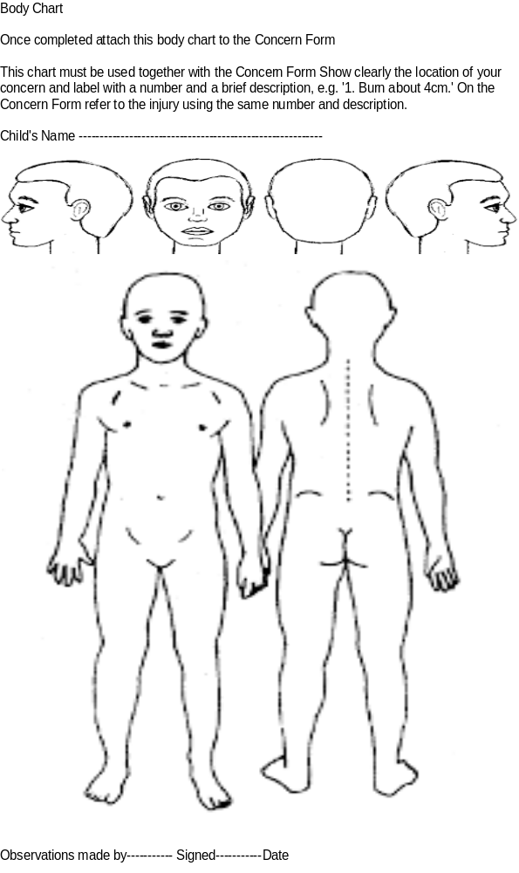

Signs and symptoms of physical injury can be indicators of abuse, however there may be other reasons they are not fail-safe mechanisms.
Red indicates a possible non-accidental injury.
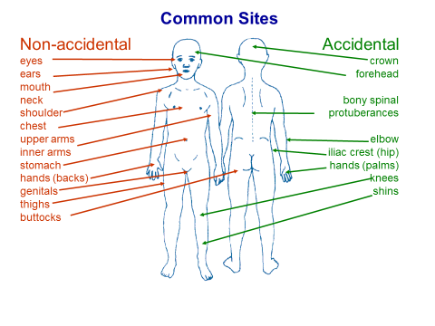
Green is the more usual sites for accidental injuries.

Appendix 6: Searching pupils for prohibited and banned items
Suspicion that a pupil is in possession of a prohibited (or banned item listed in the School Behaviour policy)

Explained to pupil that a search will be carried out.
Pupil gives consent

YES
N0
Search is carried out – removal of only outer clothing and search of possessions (lockers bags etc)
No search but Behaviour policy sanction implemented
Search only for prohibited items

Is there is a suspicion that the pupil is carrying an item related to a criminal offence , police officers should be called and a strip search may be considered. An appropriate adult MUST be present

If an item is found, then the sanctions implemented according to the school Behaviour Policy

Note:
- All searches should be carried out with pupil’s permission if possible and should be undertaken by a member of staff who has been authorised to do so by the headteacher.
- The person carrying out the search should be the same sex as the pupil and searches should be witnessed by a second adult member of staff.
- Searches will only require pupils to remove outer clothing (i.e., not worn wholly next to the skin or immediately over underwear).
- Strip searches can only be carried out by police officers. School staff should retain a duty of care/well-being for the pupil involved at all times.
- An appropriate adult must be present e.g., the parent/carer or a staff member (the school should facilitate the parent/carer as an appropriate adult if possible).
- Unless requested otherwise by the pupil, the appropriate adult should be the same sex as the pupil being searched.
- A record of all searches for prohibited items must be made by the DSL and the parents informed.

Guidance:
If there is a suspicion that the pupil is carrying an item related to a criminal offence, call the police. Do not investigate further. Police Officers attending may consider a more thorough search using their powers under the Police and Criminal Evidence Act (PACE). In these circumstances an Appropriate Adult MUST be made available for the pupil and must be present during this procedure.
An Appropriate Adult would not be required if the police are attending the school to support a child (pupil) who has reported a crime or is the victim of a crime. For example, police officers from the Child Abuse Investigation Team (CAIT), or the reporting of a street robbery where the pupil has been the victim of this act.
See KCSiE 2026 When to call the police. Guidance for Schools and Colleges.
What is the aim of an appropriate adult?
The role of the appropriate adult is to safeguard the interests, rights, entitlements and welfare of children and vulnerable people who are suspected of a criminal offence, by ensuring that they are treated in a fair and just manner and are able to participate effectively.
Here is how the law describes the role:
- "To safeguard the rights, entitlements and welfare of juveniles and vulnerable persons to whom the provisions of this and any other Code of Practice apply”. Police and Criminal Evidence Act 1984 Code C 1.7A
- “To act as appropriate adults to safeguard the interests of children and young persons detained or questioned by police officers”. Crime and Disorder Act 1998 s.38(4)
https://www.appropriateadult.org.uk

APPENDIX 7: Brook Sexual Behaviours Traffic Light Tool

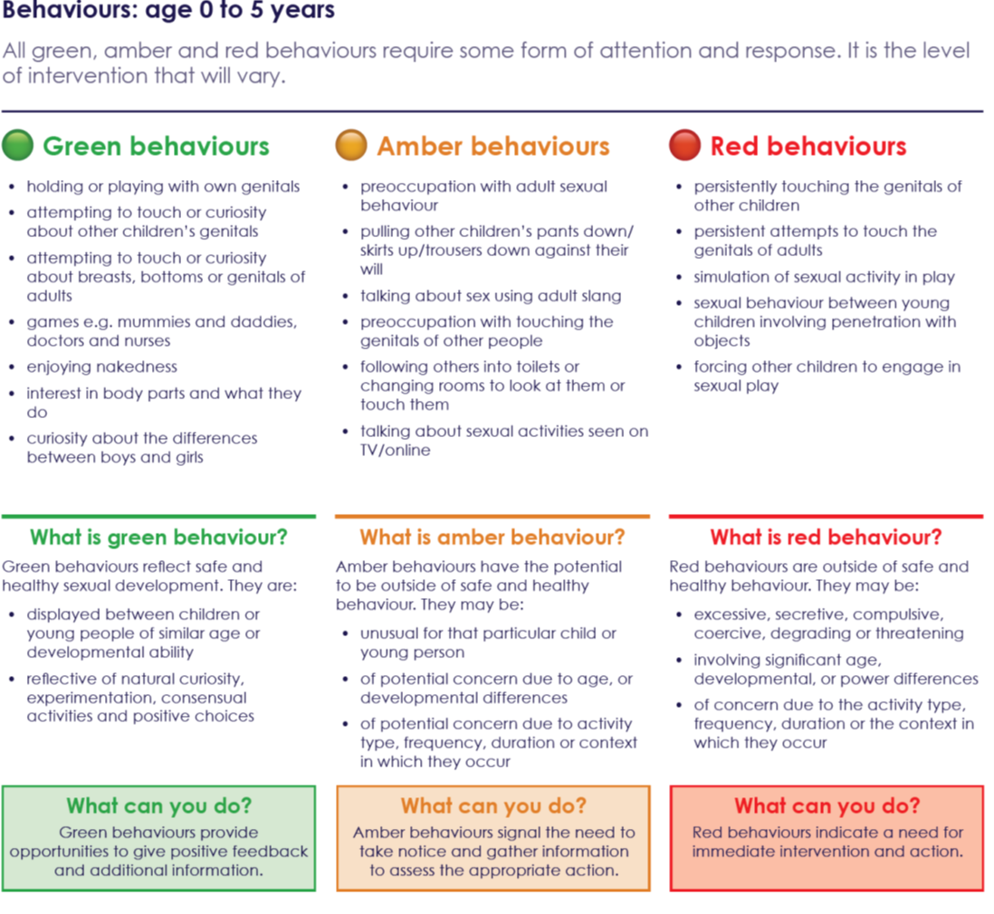

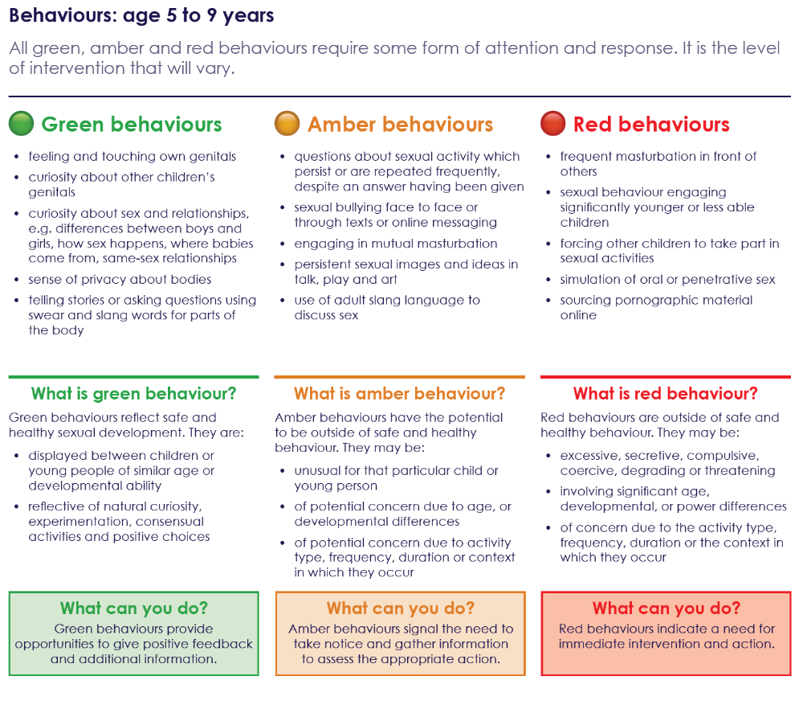

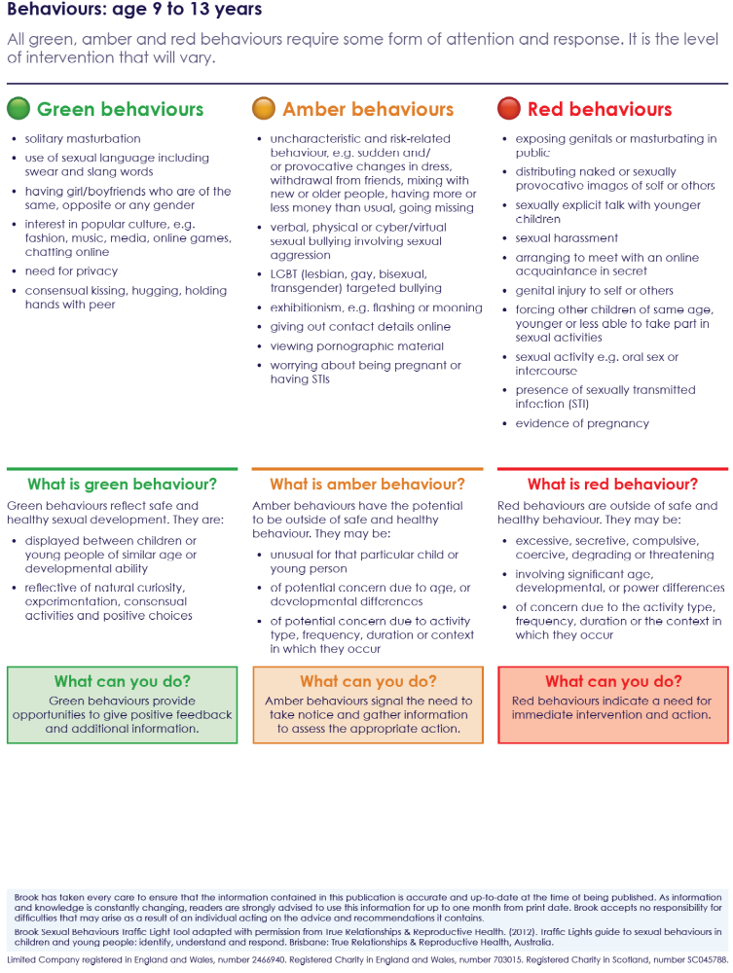

Appendix 8: How the school meets the Digital Technology in Schools’ Standards
The school provides a safe environment to learn and work, and filtering and monitoring and filtering are key elements to safeguard staff and pupils from potentially harmful and inappropriate online material.
- KCSiE 2026 requires the DSL to have lead responsibility for understanding the filtering and monitoring systems and processes. In KCSiE 2026 the list of additional guidance on “appropriate” filtering and monitoring has been expanded to include the DfE guidance Generative AI: product safety expectations.
- The DfE published guidance for Meeting Digital and Technology standards requires a member of SLT and governor to assume responsibility that the standards are met and that the roles and responsibilities for staff and third parties/external providers are assigned.
- The school is directly responsible for ensuring they have the appropriate level of security protection procedures in place in order to safeguard their systems, staff and learners and review the effectiveness of these procedures periodically to keep up with evolving cyber-crime technologies.
This school has the following assigned:
SLT - The procurement of the filtering and monitoring systems, decision making on restrictions/blocking/filtering, reviewing the effectiveness and overseeing reports are the responsibility of the SLT. They are also responsible for ensuring staff understand their role through staff training, adherence to policy and procedure and reporting concerns.
DSL – the DSL is responsible for receipt of filtering and monitoring reports, following up on safeguarding concerns and ensuring checks are undertaken by IT providers on the filtering and monitoring systems.
Reviews at least every academic year (as set out below) should be carried out by the SLT member responsible for filtering and monitoring, with the support of the school's designated safeguarding lead and IT support.
IT service provider - is responsible for maintaining, checking and reviewing the filtering and monitoring systems, providing filtering and monitoring reports to the DSL, implementing agreed actions following any concerns or checks to the system.
In meeting this standard, the school has agreed to:
- Undertake an annual review (e.g. LGFL online safety risk assessment and audit or 360 safe website or similar) to identify risks and ensuring adherence to policy. ensure that a review of their effectiveness is carried out at least once every academic year. They should include checks that filtering is working appropriately on all internet-connected devices in all relevant locations, and a record should be kept of these checks.'
- Provide regular staff training for online safety.
- Ensure pupils are given the knowledge and skills to understand how to keep themselves safe online and learn about their digital footprint and the implications.
- The school sets out safety considerations and legal responsibilities when using Generative AI (teacher-facing or pupil-facing). Further details can be found at Generative artificial intelligence (AI) in education - GOV.UK. – Staff may use trusted sites to help produce planning and resources. Staff ensure that no personal pupil information is used.

- To ensure online safety is promoted in school and is an embedded theme across all relevant curricular learning activities.
- Provide regular opportunities for communication with parents/carers to raise their awareness of online safety issues and deliver workshops or share information on relevant online safety topics and trends.
- Schools can use the department’s ‘plan technology for your school service’ to self- assess against the filtering and monitoring standards and receive personalised recommendations on how to meet them (KCSiE update 2025).
- Guidance on e-security is available from the National Education Network and National Cyber Security Centre (NCSC) to support schools to help them improve their resilience against cyber-attacks.

According to Section 10 of the Children Act 1989, a duty to cooperate.
The school will work openly with parents/carers as far as possible, but it reserves the right to contact Children’s Social Care or the police, without notifying parents if this is believed to be in the child’s best interests.
Further information can be found in the mental health and behaviour in schools’ guidance
PACE Code C 2019
searching screening and confiscation July 2022
Changes to the Voyeurism (Offences) Act 2019 criminalises the act of 'up skirting'. The Criminal Prosecution Service (CPS) defines 'up skirting' as a colloquial term referring to the action of placing equipment such as a camera or mobile phone beneath a person’s clothing to take a voyeuristic photograph without their permission.
Please note Working together to improve school attendance is now statutory guidance (KCSiE 2026).
See Appendix 1 in this policy for brief details of types of abuse and KCSiE 2026 (part 1 and Annex B for greater detail).
Addition as per KCSiE 2026.
KCSiE 2026 also see Appendix 4 attached to this policy.
This applies to behaviours outside the school environment, in the adult’s personal, professional or community life.
Information sharing advice for practitioners providing safeguarding services to children, young people, parents and carers
Further detail to be found in Keeping children safe in education 2026 (comes into force from 1 September 2026) - Annex B
Mandatory duty to report FGM
CME statutory guidance and Working together to improve school attendance which is now statutory guidance (KCSiE 2026).
March 2024 New definition of extremism.
New definition for Radicalisation.
Revised Prevent Duty guidance for England and Wales latest update 2024
See Annex B Keeping children safe in education 2026 (comes into force from 1 September 2026) for further information.
Further information on the signs of a child’s involvement in county lines is available in guidance published by the Home Office Child exploitation disruption toolkit (accessible) - GOV.UK and County Lines Toolkit For Professionals | The Children's Society
Other indicators found in Keeping children safe in education 2026 (comes into force from 1 September 2026) Annex B.
Further information in Keeping children safe in education 2026 (comes into force from 1 September 2026) Part 5.
As per KCSIE 2026
Meeting Digital and Technology standards 2022 (updated 2025)

